

SANATHAN NARAYANAN

17BCE1094

Dr. Muthumanikandan V

A1 + TA1

CSE4014 – High Performance Computing

Project Review - 1

Enhance Image Denoising Deep Neural Network by Unsharp Masking

**Abstract:**

Nowadays, videos and images have become integral parts of life. Usage of images can range from casual capturing of moments to serious military and biomedical fields.

So, this leads to an increasing demand visually pleasing and accurate pictures.

But we can see that almost all pictures captured by cameras would be corrupted by noise.

Even though the advances in hardware like optics, etc have reduced noises, software denoising is still a popular study

So, this project would aim to denoise images to provide greater clarity than the existing methods.

This project aims to bring about improvement in the existing system by pre-processing the images (like blurring) before hand to remove the noise more efficiently.

Here the pre-processing would be done only up to the requirement as more of it can cause loss in clarity of the image.

After the pre-processing of the image, it will be sent to the Deep Neural Network module, which would denoise it to produce image with acceptable quality even for medical standards.

Pre-processing is especially done so that the image de-noise algorithm can easily remove the noise from the image without causing additional noises, etc.

Chapter – 1 - Introduction

The project done by Sanathan et. al aimed to denoise image using the deep neural network concepts with an enhancement in the existing system.

This would be very useful especially in medical applications, where the captured image may get affected by noise.

Denoising an image should result in minimal loss of quality of the image

Noise occurs usually because of cheap sensors, moving sensors, moving objects, low lighting, etc

This project used High Performance Computing (Computing on Large Datasets), Image Processing – Segmentation, Image Processing – Denoising Image as its Domains

Image denoising assumed a significant job in present day image handling frameworks. The previous couple of decades witness extraordinary accomplishments in this field [1], and techniques that use self-similarity furthermore, non-local attributes of characteristic images have attracted much consideration because of their straightforwardness and adequacy.

As of late, incredible accomplishment is made by the notable BM3D calculation [2] which consolidates the nonlocal channels [3] and change space methods [4]. Techniques that offer comparable thought and technique of BM3D are broadly received to deal with grayscale picture [5] – [7].

At the point when the information is colour picture (sRGB) or on the other hand multispectral image that contains rich data and conveys progressively loyal portrayal for genuine scenes, straightforwardly applying the grayscale denoising calculation to each channel [3] or on the other hand, large band [8] regularly neglects to create attractive outcomes.

What's more, along these lines endeavours to comprehend and address decrease issue have been produced using a few alternate

points of view.

Techniques that fall into such classification are generally considered with various priors and regularization. Quickly, [10] proposes a multichannel nonlocal fusion (MNLF) approach, [11] presents colour line to display the connection among neighbouring pixels furthermore, channels, and [12] considers the spatial and phantom conditions. Low position priors are likewise embraced in a few aggressive techniques [13]–[15]. Additionally, to dodge vectorization of picture fix, some ongoing works consolidate tensor portrayal [16] with higher request worth disintegration (HOSVD) [7], [17], [18], low rank tensor approximation (LRTA) system [19], Laplacian Scale Mixture displaying [20] and Hyper-Laplacian regularization [21]. Notwithstanding the plan of denoising system, demonstrating is likewise significant. A large portion of existing strategies consider added substance white Gaussian (AWGN) and some proficient estimation strategies [2], [3] can be utilized. Additionally, some non i.i.d. Gaussian denoisers are proposed for separating Poission noise [4], blended Gaussian [5]. Actually, noise in real world pictures may be multiplicative signal [17], making noise displaying and estimation considerably more perplexing and testing. [18] and [19] consider the non-direct preparing steps in the camera pipeline in the noise model, and [10]–[12] consolidate outer and interior parts. A few strategies [13]–[16], including the outstanding programming tool Neat Image (NI) are produced for commotion decrease of true real world images. Other than the regular domain transform approaches, numerous later aggressive strategies [7]–[10] depend on the approach of profound learning procedure as a ground-breaking highlight extraction device.

Numerous focused techniques [13], [15], try to approach the ideal execution by displaying the excess what's more, relationship at gathering level with some iterative procedures [50] and an enormous number of comparable datasets. Be that as it may, impact of the fix level portrayal is less considered. In spite of the fact that the utilization of tensor portrayal may help safeguard some structure data, the direct collapsing may not completely misuse the relationship among all groups. In this paper, they examine the potential and impact of fix level portrayal, what's more, build up a general plan with the network. We exhibit that the mix of an appropriate global fix premise and neighbourhood PCA method can create exceptionally focused execution as far as both productivity and adequacy. Augmentation to non-Gaussian noise in hyperspectral image is moreover talked about. Attempts have been made to lessen computational multifaceted nature, and all outcomes revealed in their paper could be repeated productively.

Chapter – 2 - Related Works

Utilizing a 4D change in condition (5) for CBM3D might be a small befuddling, in light of the fact that after a specific shading space change, the first R, G, B diverts are figured separately in the new shading space, which additionally holds for 4DHOSVD assuming all mode changes are gotten. Along these lines, it might be normal to re-plan (5) as free channel-wise (third-request tensor) change. In this segment, we initially sum up patch level portrayal by means of square askew lattice, at that poit talk about the appropriate decision for fix level premise, and clarify how it could be appropriately fused into the square askew portrayal what's more, proficiently connected to picture denoising.

Some ongoing denoising systems [5], [6] think about data of the entire picture and get familiar with a worldwide portrayal to render more power. CBM3D shares a similar thought by applying a pre-characterized change for all patches. t-SVD is moreover a reasonable option as a worldwide premise since it protects the spatial data, and the pre-characterized FFT change along the third mode could make it less touchy to the variety of commotion. The worldwide fix portrayal can be prepared with arbitrarily inspected patches, however for effortlessness, all the reference patches are utilized. In the event that the fix portrayal is procured, at that point gathering and community-oriented separating could be seen as a component extraction also, fix arrangement process that deals with nonlocal likeness. Consequently, some basic and compelling order strategy, for example, PCA can be used. We term the blend of worldwide t-SVD premise and nearby PCA change as 'multispectral t-SVD (MSt-SVD)', and nitty gritty usage is given in Algorithm 1 and Fig. 3. Looking at the FFT lattice W in (19) and the adversary shading mode change lattice UT shade of CBM3D in (6), it tends to be seen that the main cut in the Fourier area relating to the primary column of W can be viewed as luminance channel, along these lines like CBM3D, the gathering procedure and the preparation of neighbourhood PCA can be performed by considering just the primary cuts of all patches in the Fourier area. Clearly, this execution can spare 2 3 computational time on gathering and preparing. This proficient adjustment of MSt-SVD for shading picture is named 'shading MSt-SVD' (CMSt-SVD), and its execution is advised in Calculation 2. Curiously, the relationship among nonlocal t-SVD, CBM3D what's more, 4DHOSVD is in this manner built up utilizing square slanting portrayal in the Fourier space.

The agent thought about techniques for shading picture denoising include: CBM3D [9], 4DHOSVD1 (hard-thresholding) [7], WTR1 [1], Neat Image (NI), TNRD [7], GID [2], MCWNNM [13], TWSC [15], LSCD [8], and LLRT [1]. Three agent neural system based techniques MLP [17], DnCNN [18] and FFD-Net [10] are likewise incorporated into our examination. Considering the computational multifaceted nature of some thought about strategies and for reasonable correlation, all techniques are tuned to deliver their best normal outcomes, and the information commotion level of some Gaussian denoisers is recorded in Table III. In useful execution, in any case, ought to be tuned for each picture, so to all the more likely comprehend the viability of best in class CBM3D, the best consequence of CBM3D on each picture is accounted for, and this execution is named 'CBM3D best'. PSNR and SSIM records are utilized for target assessment.

Investigations on CC15: The calibrated aftereffects of TNRD, MLP and DnCNN in [13] are utilized. PSNR aftereffect of each picture and normal computational time are recorded in a table, also, visual assessments are given in few figures. Table is used to demonstrates that the straightforward CMSt-SVD reliably beats MSt-SVD and 4DHOSVD1, and both MSt-SVD and CMSt-SVD can deliver aggressive execution in terms of both viability and productivity. Figure 4 demonstrates that the delegate low-position based technique LLRT and the 4CBM3D and LSCD utilize a C++ work, while different techniques are actualized simply with MATLAB. coding plan TWSC produce acceptable outcomes in homogenous locales, in light of the fact that the hidden clean fixes share much comparative component, and in this manner can be displayed as a low-position or inadequate coding issue. In any case, as outlined in Figure 5, when the real world image contains more subtleties or neighbourhood varieties, clear over-smooth impacts can be watched. Strikingly, the best in class neural system FFD-Net shows comparative impacts. Additionally, contrasted and CBM3D and CMSt-SVD, the nearby 4DHOSVD change is all the more effectively influenced by the nearness of pixels, which is consolidated in the preparation procedure of pixel colour mode change. Analyses on CC60, Xu-100 and our datasets: Tables are present, which list the normal PSNR and SSIM estimations of a few focused strategies. Clearly CMSt-SVD still exhibits a standout amongst other execution. Their visual assessments further represent the impacts of the inadequate coding plan and condition of neural system, while one of the figure demonstrates that numerous focused techniques including NI, 4DHOSVD, MCWNNM and GID produce coloured imaged which are traditional somewhat, which is like their perception in figures discussed

In their paper, they assemble the relationship among state-of-the-art changes with square corner to corner portrayal, and also examine the correct decision of patch level change.

According to this, and experiments, two basic and viable strategies that consolidate a worldwide t-SVD premise and neighbourhood PCA change have been proposed.

The proposed MSt-SVD and CMSt- SVD use progressively spatial data and produce aggressive execution with cutting edge channels regarding both proficiencies also, adequacy.

As of late, some factual properties of tensor decay are contemplated, it is fascinating to examine a further comprehension of both shading picture and multispectral picture denoising with square corner to corner portrayal.

Moreover, their future research additionally incorporates characterization and related picture reclamation issues

Chapter – 3 – System Design

This project aims to bring about improvement in the existing system by pre-processing the images (like sharpening) before hand to remove the noise more efficiently.

Here the pre-processing would be done only up to the requirement as more of it can cause loss in clarity of the image.

After the pre-processing of the image, it will be sent to the Deep Neural Network module (Fig. 3), which would denoise it to produce image with acceptable quality even for medical standards. (Fig, 10, 11)

Pre-processing is especially done so that the image de-noise algorithm can easily remove the noise from the image (Fig. 2,6) without causing additional noises, etc.

All this would be done using MATLAB r2017b with MATLAB deep learning toolbox

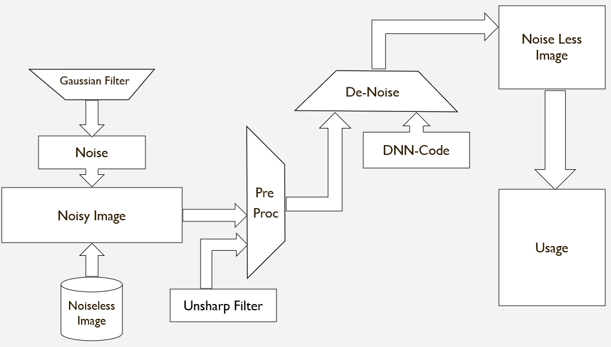

Architecture Diagram of the whole system

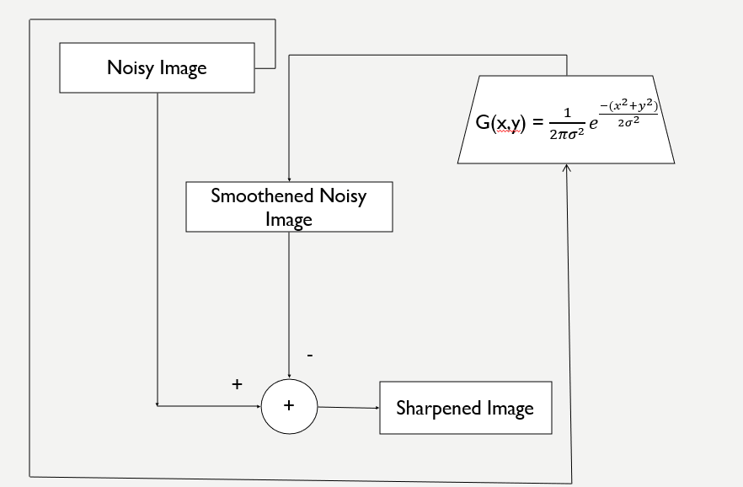

Architecture Diagram of Unsharp Masking

***Algorithm – General Approach:***

1. Start
2. Read the Noisy Image
   1. We can also get Noisy Image by Oringinal Image + Noise
3. Pre-process the Noisy Image
   1. Use UnSharp Masking to Sharpen Image
   2. Do further Pre-processing as required
4. Apply DNN to De-Noise the pre-processed Image
5. Obtain the Noiseless Image
6. Usage of the Noiseless Image
7. Stop

***Algorithm – Unsharp Masking:***

1. Start
2. Read the Noiseless Image
3. Blur the image using Gaussian Filter
   1. Use G(x,y) = $\frac{1}{2πσ^{2}}e^{\frac{-{(x}^{2}{+y}^{2})}{2σ^{2}}}$ Eqn. 1. in all pixel values to get smoothened image
4. Now Subtract this smoothened image from Original image to get Sharp image as:
   1. S(x,y) = O(x,y) – G(x,y) -> Eqn. 2.
5. Send sharpened image to DNN
6. Stop

Mathematical Proof

We use the existing Gaussian filter to blur the image first:

G(x,y) = $\frac{1}{2πσ^{2}}e^{\frac{-{(x}^{2}{+y}^{2})}{2σ^{2}}}$ (1)

Then we subtract this blurred image from the original image to create sharpened image using the unsharp masking technique.

S(x,y) = O(x,y) – G(x,y) (2)

Now, when the images are converted into histograms, we can find that the histograms of the original and pre-processed images are more similar than the histograms of the original and only DNN images.

This can be easily noted in the tips of the graph in the x-axis, where the slopes of the tips are maintained better in the pre-processed denoised image.

Chapter – 5 – Performance Evaluation

MATLAB r2017b is used to perform this process. MATLAB deep learning toolbox is also used in this process.

Many images of cars are taken as dataset (as we would need clear number plates for later identification).

An image of a car is read and then, blurred using ‘Gaussian Filter’.

This blurred image is subtracted from the original image to produce a sharper image than original which is unsharp masking. (Fig. 3)

This pre-processed image is given to DNN for denoising. We have proved in this paper that, pre-processing using unsharp masking enhances the performance of DNN.

The final obtained image (Fig. 5, 10) can now be used for many purposes like medical, satellite, military, etc.

Chapter – 4 – Implementation Results



Fig. 1. Original Image



Fig. 2. Noisy Image



Fig. 3. Sharpened Noisy Image by Unsharp Masking



Fig. 4. Denoised Noisy Image



Fig. 5. Denoised Sharpened Noisy Image



Number of pixels

Gray Level

Fig. 6. Histogram of Noisy Image



Number of pixels

Gray Level

Fig. 7. Histogram of Denoised Blurred Noisy Image



Number of pixels

Gray Level

Fig. 8. Histogram of Denoised Noisy Image



Number of pixels

Gray Level

Fig. 9. Histogram of Original Image



Number of pixels

Gray Level

Fig. 10. Histogram of Denoised Sharpened Noisy Image





Number of pixels

Gray Level

Fig. 11. Histogram of Denoised Sharpened Noisy Image vs of Original Image



Number of pixels

Gray Level

Fig. 12. Histogram of Denoised Sharpened Noisy Image vs of Denoised Noisy Image





Number of pixels

Gray Level

Fig. 13. Histogram of Denoised Sharpened Noisy Image vs of Denoised Blurred Noisy Image

So, we can see that, the Denoised Sharpened Noisy Image’s histogram retains more features of the original image’s histogram than the one which is without the pre-processing.

This can be noted especially from the ends of the histograms. (Fig. 11)

The pre-processed histograms are less slanted compared to only DNN, so, this pre-processed image’s histogram matches/retains the features of original image better as the original image’s histogram is also less slanted.

Chapter – 6 – Conclusion and future work

As we can see that, sharpening the noisy image before giving it to DNN enhances the process.

The Image Histogram of pre-processed Denoised Image retains features better than the one without pre-processing.

This would be useful in medical applications where every minute detail needs to be preserved

This would also be useful in satellite geographical analysis, military analysis.

The future work of this project would be to increase the speed of the execution, as pre-processing would consume more time.

Consumption of time will increase drastically for bulk images.

Also, even more enhancement can be researched and achieved.

References

[1] P. Milanfar, “A tour of modern image filtering,” IEEE Signal Process.

Mag., vol. 30, no. 1, pp. 106–128, 2011.

[2] K. Dabov, A. Foi, V. Katkovnik, and K. Egiazarian, “Image denoising by

sparse 3-d transform-domain collaborative filtering.” IEEE Trans. Image

Process., vol. 16, no. 8, pp. 2080–2095, 2007.

[3] A. Buades, B. Coll, and J. M. Morel, “A review of image denoising

algorithms, with a new one,” Multisc. Model. Simulat., vol. 4, no. 2, pp.

490–530, 2005.

[4] L. P. Yaroslavsky, K. O. Egiazarian, and J. T. Astola, “Transform domain

image restoration methods: review, comparison, and interpretation,” Proceedings

of SPIE - The International Society for Optical Engineering,

pp. 155–169, 2001.

[5] K. Dabov, A. Foi, and K. Egiazarian, “Video denoising by sparse 3d

transform-domain collaborative filtering,” in Proc. Eur. Conf. Signal

Process., Sep. 2007, pp. 145–149.

[6] S. Gu, L. Zhang, W. Zuo, and X. Feng, “Weighted nuclear normminimization with application to image denoising,” in Proc. IEEE Conf. Comput. Vis. Pattern Recognit. (CVPR), 2014, pp. 2862–2869.

[7] A. Rajwade, A. Rangarajan, and A. Banerjee, “Image denoising using

the higher order singular value decomposition,” IEEE Trans. Pattern

Anal. Mach. Intell., vol. 35, no. 4, pp. 849–862, 2013.

[8] R. Yan, L. Shao, and Y. Liu, “Nonlocal hierarchical dictionary learning

using wavelets for image denoising,” IEEE Trans. Image Process.,

vol. 22, no. 12, pp. 4689–4698, 201

[9] K. Dabov, A. Foi, V. Katkovnik, and K. Egiazarian, “Color image

denoising via sparse 3d collaborative filtering with grouping constraint in

luminance-chrominance space,” in Proc. IEEE Int. Conf. Image Process.

(ICIP), vol. 1, 2007, pp. I–313–I–316.

[10] J. Dai, O. C. Au, L. Fang, C. Pang, F. Zou, and J. Li, “Multichannel

nonlocal means fusion for color image denoising,” IEEE Trans. Circuits

Syst. Video Technol., vol. 23, no. 11, pp. 1873–1886, 2013.

[11] W.-C. Tu, C.-L. Tsai, and S.-Y. Chien, “Collaborative noise reduction

using color-line model,” in Proc. IEEE Int. Conf. Acoust. Speech Signal

Process. (ICASSP), May 2014, pp. 2465–2469.

[12] P. Zhong and R. Wang, “Multiple-spectral-band crfs for denoising junk

bands of hyperspectral imagery,” IEEE Trans. Geosci. Remote Sens.,

vol. 51, no. 4, pp. 2260–2275, 2013.

[13] J. Xu, L. Zhang, D. Zhang, and X. Feng, “Multi-channel weighted

nuclear norm minimization for real color image denoising,” in Proc.

IEEE Int. Conf. Comput. Vis. (ICCV), 2017, pp. 1096–1104.

[14] W. He, H. Zhang, L. Zhang, and H. Shen, “Total-variation-regularized

low-rank matrix factorization for hyperspectral image restoration,” IEEE

Trans. Geosci. Remote Sens., vol. 54, no. 1, pp. 178–188, 2016.

[15] J. Xu, L. Zhang, and D. Zhang, “A trilateral weighted sparse coding

scheme for real-world image denoising,” CoRR, vol. abs/1807.04364,

2018. [Online]. Available: http://arxiv.org/abs/1807.04364

[16] T. G. Kolda and B. W. Bader, “Tensor decompositions and applications,”

SIAM Rev., vol. 51, no. 3, pp. 455–500, 2009.

[17] L. R. Tucker, “Some mathematical notes on three-mode factor analysis,”

Psychometrika, vol. 31, no. 3, pp. 279–311, 1966.

[18] L. D. Lathauwer, B. D. Moor, and J. Vandewalle, “A multilinear singular

value decomposition,” SIAM J. Matrix Anal. Appl., vol. 21, no. 4, pp.

1253–1278, 2000.

[19] N. Renard, S. Bourennane, and J. Blanc-Talon, “Denoising and dimensionality

reduction using multilinear tools for hyperspectral images,”

IEEE Geosci. Remote Sens. Lett., vol. 5, no. 2, pp. 138–142, 2008.

[20] W. Dong, G. Li, G. Shi, X. Li, and Y. Ma, “Low-rank tensor approximation

with laplacian scale mixture modeling for multiframe image

denoising,” in Proc. IEEE Int. Conf. Comput. Vis. (ICCV), 2015, pp.

442–449.